Interpreter

Behavioral Design Pattern

**What is an Interpreter:**

1. Used when we want to process a simple language with rules or grammar. Example: File access requires user role and admin role.
2. Allows us to represent the rules of language or grammar in a data structure and then interpret sentences in that language.
3. Each class in this pattern represents a rule in the language. Classes also provide a method to interpret and expression.

**UML:**

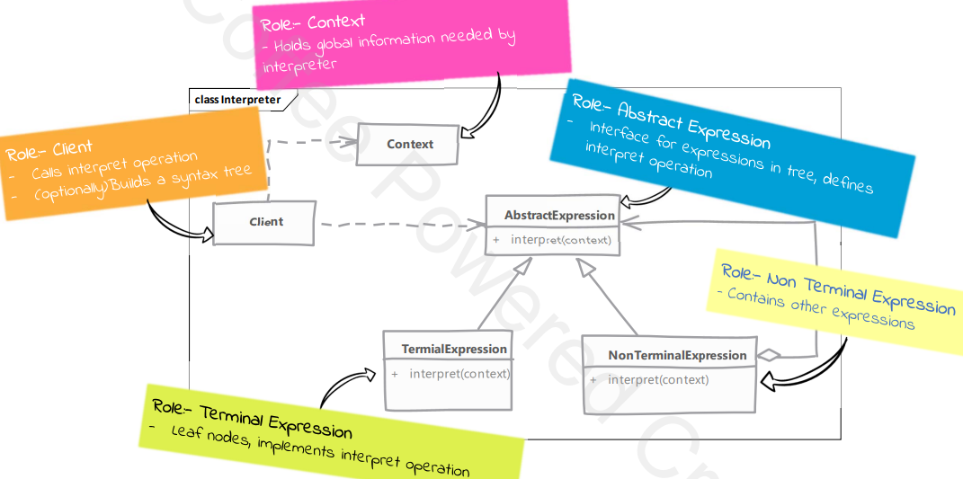

**Pitfalls:**

1. Class per rule can quickly result in large number of classes.
2. Not suitable for languages with complex grammar rules.
3. Very specific to a particular kind of problem of interpreting languages.

**Example:**

